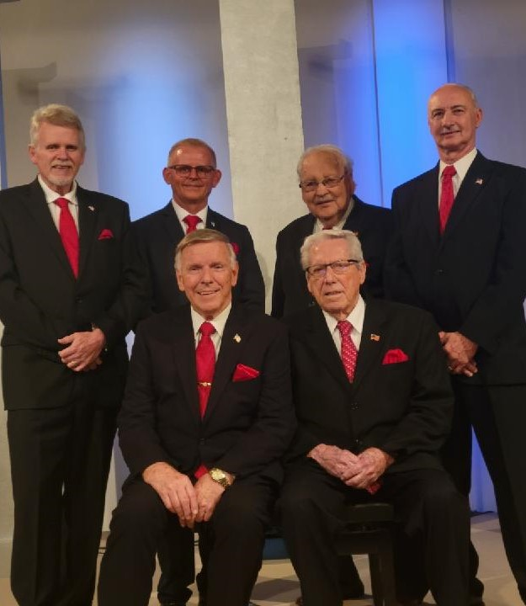
www.socialsecurityboys.com

TIME_________________________

DATE_________________________

PLACE________________________

